# StreetCoding and i*GNOS Project

streetcoding.it

The StreetCoding project aims to spread computer culture, promote the development of innovative applications, and facilitate the understanding of technological architectures. Inspired by the street art movements, StreetCoding stems from passion and enthusiasm, based on the principles of hacking ethics: peer-to-peer knowledge sharing, decentralization, and free access to technology and information.  
Hacking ethics go beyond technical skills, embodying an open and collaborative approach to technology, where knowledge is shared without barriers, and innovation is driven by collective creativity.

Through StreetCoding, both physical and virtual spaces will be created, dedicated to information sharing, collaboration, and education. Learning paths will be developed and made accessible to everyone, regardless of their level of IT knowledge, through workshops, seminars, and study groups. The initiative seeks to bridge the digital divide by offering training opportunities to those with less access to digital resources, with a particular focus on disadvantaged communities.

The project’s initial activities will include creating user-friendly online e-learning tools and platforms designed to facilitate learning for people with little technical experience. Regular meetings will be organized to promote the initiative and engage an increasing number of participants, collaborating with schools, libraries, and other associations that can host these events. Additionally, a mentorship program will be launched, involving IT experts in supporting beginners and guiding them through their first steps in coding and software development.  
The project will work closely with educational institutions, professional training bodies, organizations dedicated to digital literacy, associations, and companies in the field, spreading the philosophy upon which it is based.

**i*GNOS (interGalactics Next Operating System)** will be the project's core: an innovative operating system. The choice to develop an operating system is not accidental: building such a complex software entails the use of protocols, algorithms, and structures that encompass every aspect of digital knowledge. i*GNOS will not be a replica of existing systems like Windows, Linux, or MacOS, but a distributed and cooperative system, designed on the latest technologies. The idea is to create an ecosystem of digital devices that collaborate with each other, sharing information, distributing tasks, and replacing each other in case of failures, just like a community of people.

For the realization of this system, innovative technologies such as blockchain for managing distributed data, machine learning algorithms, decentralized consensus policies for autonomous node management, and user interfaces compatible with the most popular Internet browsers (Chrome, Firefox, Edge, Opera) will be used. Although based on advanced technologies, i*GNOS will not start from scratch: the project will leverage already tested tools, particularly from the open-source world, to ensure a solid and shared foundation.

Acquiring the skills necessary to develop i*GNOS will be at the heart of the StreetCoding movement: courses and educational materials on technologies, tools, and languages will be offered, meetings dedicated to system structuring, shared coding sessions, and promotional moments of the core ideas will be organized.

Regarding the project’s financial sustainability, StreetCoding will adopt an innovative approach based on a new type of distributed crowdfunding, which is gaining popularity thanks to NFT tokens and blockchain and smart contract technologies. This financing method will allow the community to support the project in a decentralized and transparent way, creating a self-sustaining and resilient economic ecosystem. However, this method of self-financing may not be immediate or sufficient and should still be supplemented by other forms of funding, such as public and private grants.

StreetCoding and i*GNOS represent a vanguard in the field of education and technology, combining a passion for knowledge with a practical and collaborative approach. With an innovative operating system and an active and inclusive community, the project aims not only to democratize access to technology but also to build a more equitable and shared digital future.

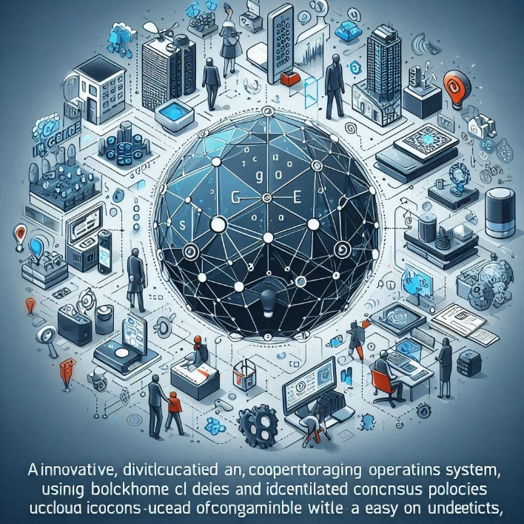The StreetCoding project aims to spread computer culture, promote the development of innovative applications, and facilitate the understanding of technological architectures. Inspired by the street art movements, StreetCoding stems from passion and enthusiasm, based on the principles of hacking ethics: peer-to-peer knowledge sharing, decentralization, and free access to technology and information.  
Hacking ethics go beyond technical skills, embodying an open and collaborative approach to technology, where knowledge is shared without barriers, and innovation is driven by collective creativity.

Through StreetCoding, both physical and virtual spaces will be created, dedicated to information sharing, collaboration, and education. Learning paths will be developed and made accessible to everyone, regardless of their level of IT knowledge, through workshops, seminars, and study groups. The initiative seeks to bridge the digital divide by offering training opportunities to those with less access to digital resources, with a particular focus on disadvantaged communities.

The project’s initial activities will include creating user-friendly online e-learning tools and platforms designed to facilitate learning for people with little technical experience. Regular meetings will be organized to promote the initiative and engage an increasing number of participants, collaborating with schools, libraries, and other associations that can host these events. Additionally, a mentorship program will be launched, involving IT experts in supporting beginners and guiding them through their first steps in coding and software development.

The project will work closely with educational institutions, professional training bodies, organizations dedicated to digital literacy, associations, and companies in the field, spreading the philosophy upon which it is based.

**i*GNOS (interGalactics Next Operating System)** will be the project's core: an innovative operating system. The choice to develop an operating system is not accidental: building such a complex software entails the use of protocols, algorithms, and structures that encompass every aspect of digital knowledge. i*GNOS will not be a replica of existing systems like Windows, Linux, or MacOS, but a distributed and cooperative system, designed on the latest technologies. The idea is to create an ecosystem of digital devices that collaborate with each other, sharing information, distributing tasks, and replacing each other in case of failures, just like a community of people.

For the realization of this system, innovative technologies such as blockchain for managing distributed data, machine learning algorithms, decentralized consensus policies for autonomous node management, and user interfaces compatible with the most popular Internet browsers (Chrome, Firefox, Edge, Opera) will be used. Although based on advanced technologies, i*GNOS will not start from scratch: the project will leverage already tested tools, particularly from the open-source world, to ensure a solid and shared foundation.

Acquiring the skills necessary to develop i*GNOS will be at the heart of the StreetCoding movement: courses and educational materials on technologies, tools, and languages will be offered, meetings dedicated to system structuring, shared coding sessions, and promotional moments of the core ideas will be organized.

Regarding the project’s financial sustainability, StreetCoding will adopt an innovative approach based on a new type of distributed crowdfunding, which is gaining popularity thanks to NFT tokens and blockchain and smart contract technologies. This financing method will allow the community to support the project in a decentralized and transparent way, creating a self-sustaining and resilient economic ecosystem. However, this method of self-financing may not be immediate or sufficient and should still be supplemented by other forms of funding, such as public and private grants.

**StreetCoding and i*GNOS** represent a vanguard in the field of education and technology, combining a passion for knowledge with a practical and collaborative approach. With an innovative operating system and an active and inclusive community, the project aims not only to democratize access to technology but also to build a more equitable and shared digital future.